

REPUBLIC OF CAMEROON

Peace-Work-Fatherland

MINISTER OF HIGHER EDUCATION

FACULTY OF ENGINEERING AND TECHNOLOGY

REPUBLIQUE DU CAMEROUN

Paix-Travail-Patrie

MINISRE DE L’ENSEIGNEMENT SUPERIEURE

FACULTE D’ENGENIERE ET DE TECHNOLOGIE

**Instructor: DR NKEMENI VALERY**

**DEPARMENT OF COMPUTER ENGINEERING**

**COURSE** **TITLE**: Internet and Mobile Programming

PROGRAMMING

**Task 4: THE DESIGN PHASE**

**GROUP TWO**

|  |  |
| --- | --- |
| **Names Matricule** | |
| **ETOH KIERA EKUTY** | **FE20A035** |
| **GWANA JUSLINE AKAH** | **FE20A047** |
| **LASSI FOKOU BERICE JILDO** | **FE20A054** |
| **YUVEN BRIAN** | **FE20A125** |
| **AJONG NTI MAGCELOUS** | **FE20A006** |
|  |  |

**THE DESIGN PHASE**

The design phase consists of two stages: a preliminary stage where the high-level design or architecture of the interactive system is derived: a detailed stage, where the specifics of each interaction are planned

1. **Preliminary design**

It consists of mapping out the high-level concepts such as the user, controls, interface displays, navigation mechanisms, and overall workflow. Preliminary design can also be called conceptual design, particularly in software engineering, because it is sometimes useful to organize the high level concepts into a conceptual map with their relations. It consist of the use case and class diagrams of the system.

1. **Detailed design**

This stage entails planning all the operations that take place between user and interactive system to a level where only implementation and technical details remain. It can be done by creating and refining a step-by-step list for the exchanges between the user and the system. Refinement of architectural components and interrelations to identify modules to be implemented separately. It consist of the sequence and flow diagrams of the system. All this is detailed in the UML (Unified Modelling Language diagrams) below which is modelled using the software Modelio.

1. **Preliminary design**
2. **Use case diagram**

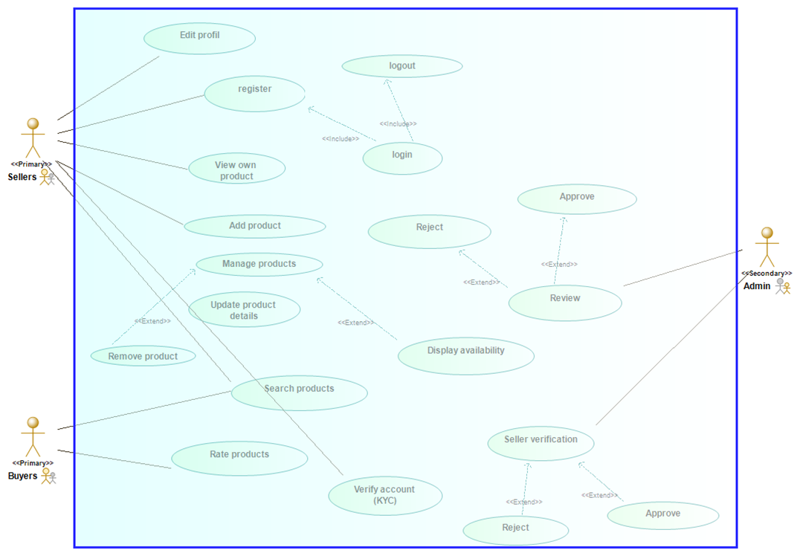

**Textual Description of the Use cases**

* Use case: Registration

Actor: Seller, Admin

Description: Seller and admin create accounts by entering their details (email and password)

* Use case: Login/Logout

Actor: Seller, Admin

Description: Summit email and password as entered during registration to access his account

* Use case: Add products

Actor: Seller

Description: User can add products they have available for sell

* Use case: Manage products

Actor: Seller

Description: User can update product information or remove products if no longer available

* Use case: Search product

Actor: Buyer

Description: The buyer can search products based on categories, price, location and availability

Seller can also search for competitors of same products

* Use case: Rating

Actor: Buyer

Description: Buyer can rate a product based on their customer service and quality of product.

* Use case: KYC verification(Know your customer)

Actor: Seller/ Admin

Description:

* The seller uploads legal documents for verification
* The admin reviews and approves or rejects the uploaded documents of the user
* Use case: Review

Actor: Admin

Description: The admin reviews products uploaded by different sellers depending on the system policy (example, No selling of illegal drugs) and either approves or rejects

1. **Class Diagram**

A class describes a group of obects with similar attributes, behavior and Relationship to other objects

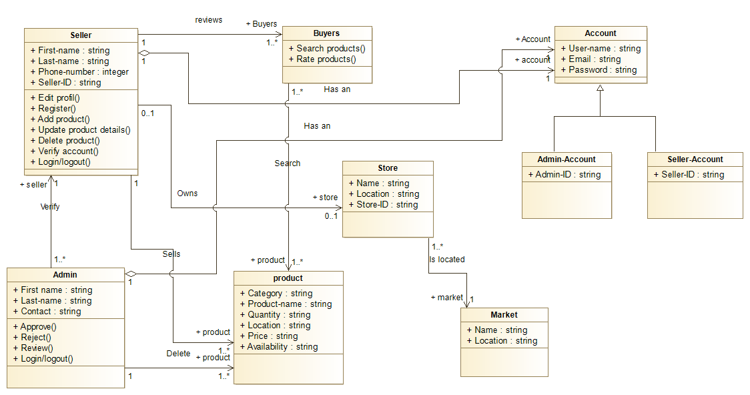

1. **Detailed Design**
2. **Activity Diagrams**

This diagams will visually present the series of actions or flow of controls in the Market management system(MMS)

Activity Diagrams consist of activities, states and transitions between activities and states Activity Diagrams describe:

* How activities are coordinated to provide a service
* The events needed to achieve some operation
* How the events in a single use case relate to one another
* How a collection of use cases coordinate to create a workflow for an organization

**Seller Account Verification**

Seller|Admin

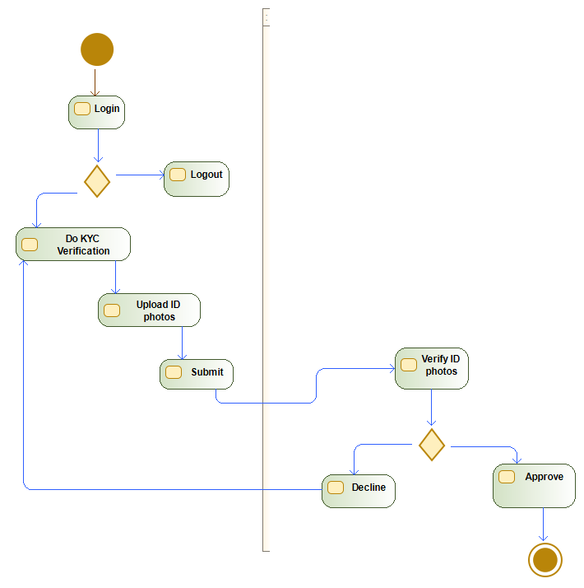

**Seller Manage product**

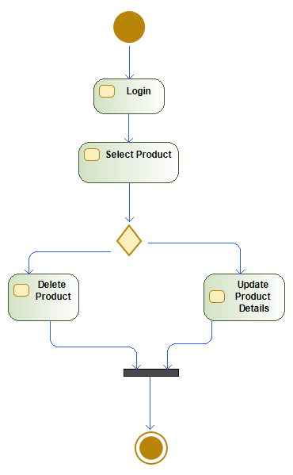

**Product search**

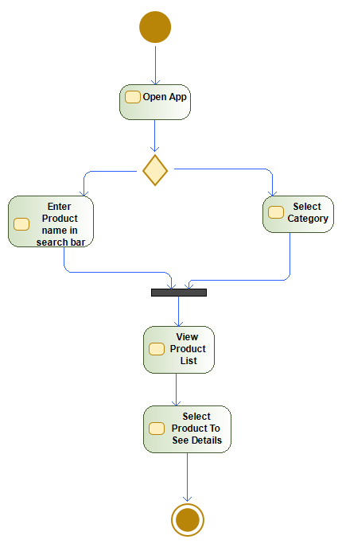

**Product Review**

**Seller|Admin**

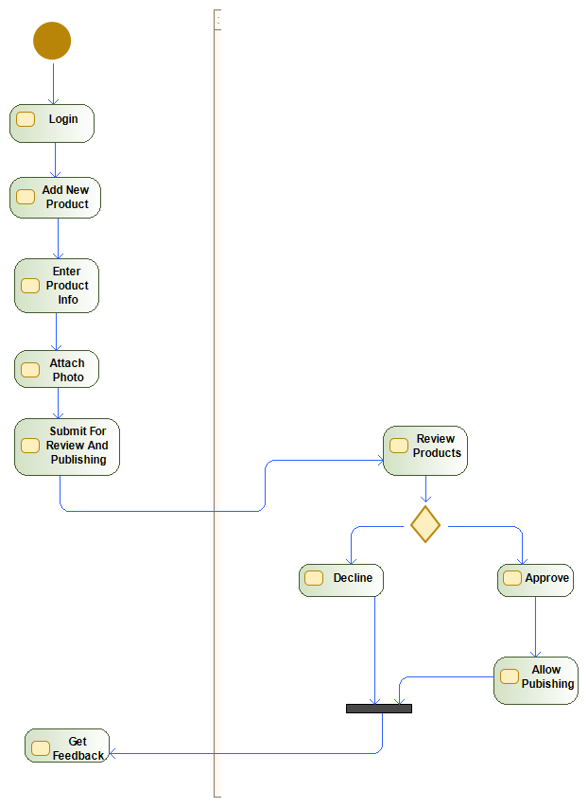

1. **Sequence Diagram**

The sequence diagram shows the flow of information of each each use case in the system

**Manage product**

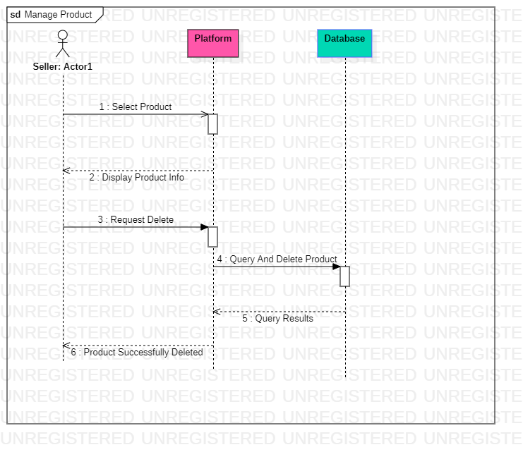

**Update Profile**

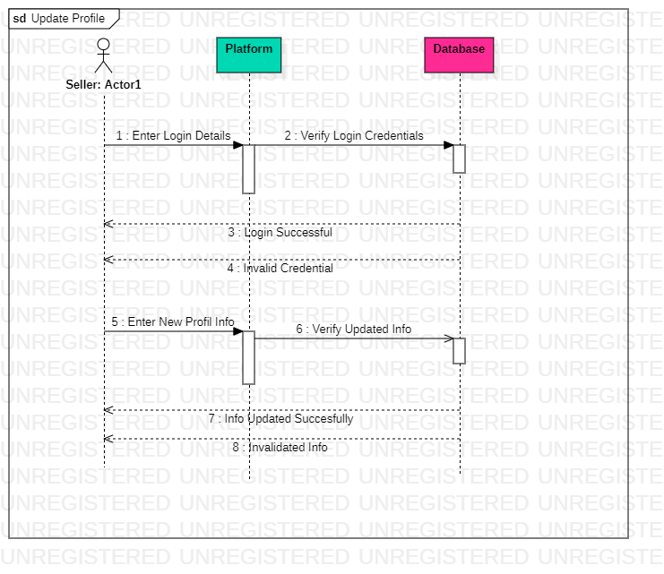

**View Product**

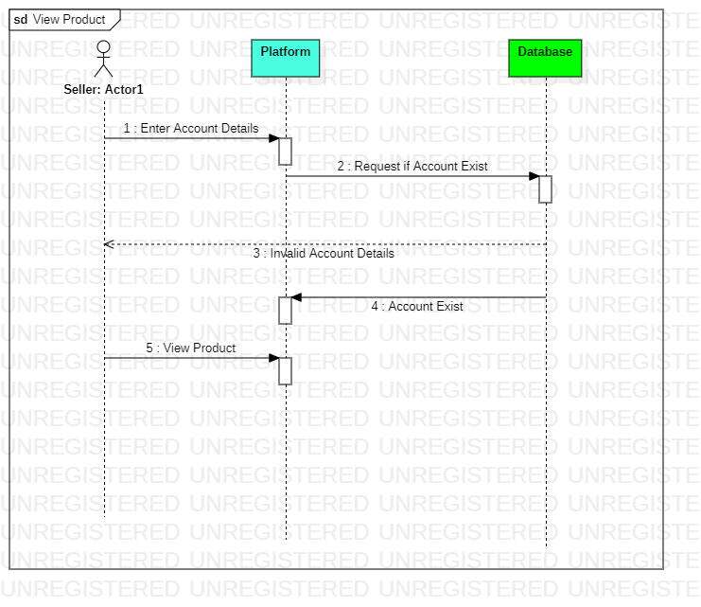

**Add product**

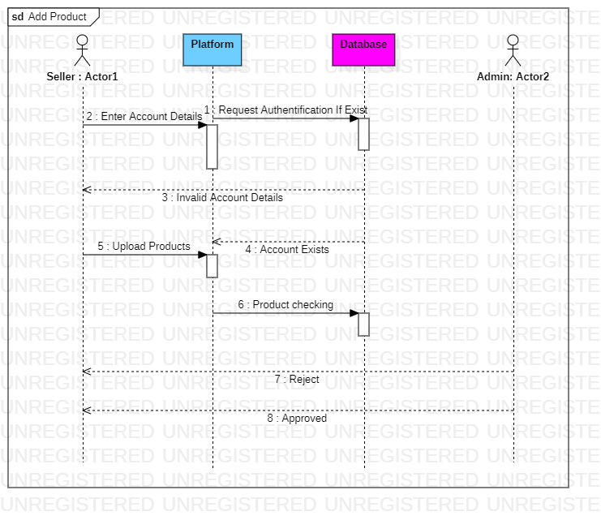

**Product Rating**

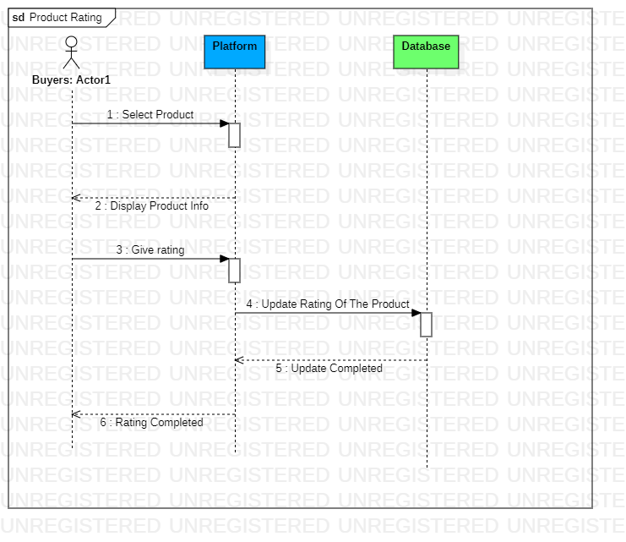

**Product Listing**

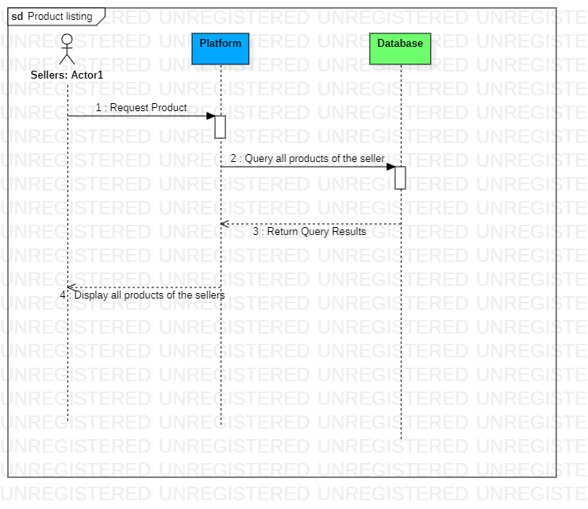

**Search Product**

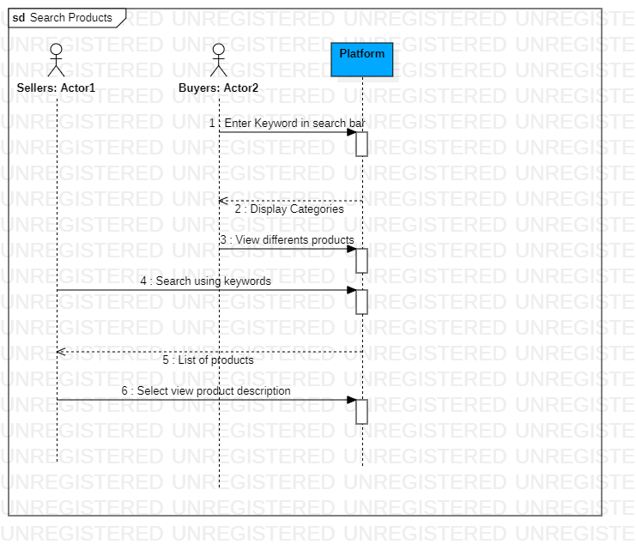

**Product Review**

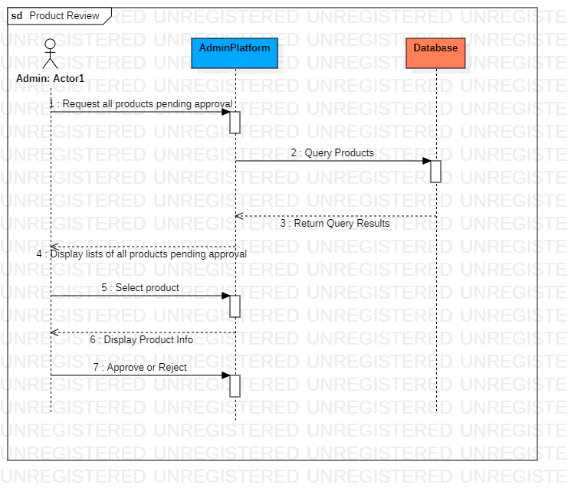

1. **Data flow Diagram**

The data flow diagram is a flowchart that shows the flow of data in a system. In our system, the data flow diagram model the product as the data, the users as the seller, customer and admin.

The system starts with the seller performing the process of posting a product. The product has to be verified by the admin for confirmation whether it is an acceptable product in the system or not. After the verification of product is done. The product is successful posted.

The customer can come in to review and product information and market where it is been sold. The customer also performs the process of rating of the products. The seller can update product details. The seller can also delete and repost in the system. The admin takes information of both the seller and the customer. For the unsigned customers, the admin record their information like cusID through cookies.

The seller is verified and approval and rejection are done by the admin. The whole system is modeled in these system as data flows from one entity to another. Taking in account the serial nature of the navigation panel.

